**Institute of Technology Tralee**

**Ord/Hons BSc. in Computing with Specialism (Group A) - Year 1**

**Continuous Assessment #2**

**Date: 29/11/11**

**Time: 9 – 11 a.m.**

**Introduction to Programming**

**Instructions:** Attempt the following question. You should use the Just BASIC IDE for coding. When you are finished you must print out your code for correction.

**________________________________________________________**

**Q1.**

A Just BASIC program is required that will prompt for and read in an arbitrary number of student marks for a continuous assessment. The user can signal the end of input by hitting return (entering empty string) for the mark. You should use a **do-until** loop for the main iteration process here.

The program must validate the mark fully, to ensure that only **whole numbers** within the range 0 to 100 inclusive are accepted by the program. Should the user enter an invalid mark for any particular student, then the program should just loop continually until a valid replacement mark has been supplied. You may use **while-wend** loop(s) for validation purposes if you wish here.

Once all the marks have been entered by the user, the program should display the following:

* The total number of valid marks entered
* The average of the valid marks entered to **2 decimal places** (allow for 3 digits before the decimal point without incurring a logical error)
* The largest valid mark entered
* The smallest valid mark entered
* The percentage of valid marks that were at least 70%

Note that should the user enter no marks at all i.e. if they hit return when prompted for the first mark, then the program should not display any of the statistical information above and should instead just display a farewell message to the user.

When coding your solution here you may find some or all of the **val()**, **str$()**, **asc()**, **mid$**()and **int()** functions particularly useful.

Using the test values as indicated in the screen shots below, the program should give you **exactly** the following output when it runs, including banners, blank lines, tabs, cleared screens etc.

Also note that there will be a few marks awarded for having a **meaningful comment at the top of the program** and for **ensuring that the program is terminated correctly** to ensure that all resources used by the program are returned to the system upon its completion.

**Sample Screen Shots**

**Upon running the program, the user gets prompted for a valid mark. They cannot get past this point until they do enter a valid mark. Here, the user ends up entering no valid mark at all and eventually hits return. This means the user gets the message indicated and no statistics are shown.**

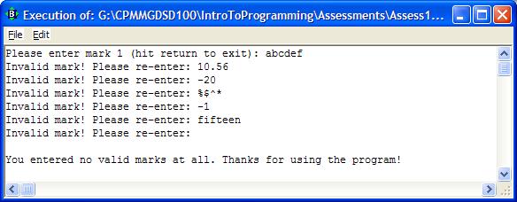

**In this run, the user enters a number of valid marks. When prompted for the fifth mark, some invalid values are entered and the validation loop continues until a valid mark (36) is entered. Then some more valid values are entered, the user hits return and the statistics are shown**

